Latency

🕒 What Is Latency in Networking?
# Source: AI Source: Provided by: [Data Path: Persons Table -> ID Column: 1, Name_En Column: Motasem Essam] -> From: [ChatGPT] on [12/18/2025]
Latency is the time delay it takes for data to travel from the source to the destination across a network. It’s typically measured in milliseconds (ms) and is a key factor in how responsive a network feels.

📦 Belongs to:
# Source: AI Source: Provided by: [Data Path: Persons Table -> ID Column: 1, Name_En Column: Motasem Essam] -> From: [ChatGPT] on [12/18/2025]
✅ Network Performance Metrics
Alongside Bandwidth, Throughput, Jitter, and Packet Loss

🧠 Definition:
# Source: AI Source: Provided by: [Data Path: Persons Table -> ID Column: 1, Name_En Column: Motasem Essam] -> From: [ChatGPT] on [12/18/2025]
Latency = the time it takes for a data packet to go from sender to receiver and (optionally) back again.

📏 Measured As:
# Source: AI Source: Provided by: [Data Path: Persons Table -> ID Column: 1, Name_En Column: Motasem Essam] -> From: [ChatGPT] on [12/18/2025]
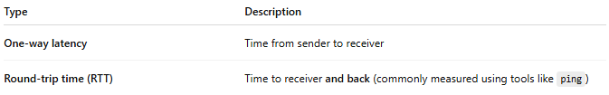
Type | Description
One-way latency | Time from sender to receiver
Round-trip time (RTT) | Time to receiver and back (commonly measured using tools like ping)

1-One-way latency

Definition
# Source: AI Source: Provided by: [Data Path: Persons Table -> ID Column: 1, Name_En Column: Motasem Essam] -> From: [ChatGPT] on [12/18/2025]
One-way latency is the time it takes for data to travel in only one direction—from a sender to a receiver—without waiting for a response.

One-way latency = time taken for a packet to go from source → destination
Unlike RTT, it does not include the return trip.

One-way Latency vs RTT
# Source: AI Source: Provided by: [Data Path: Persons Table -> ID Column: 1, Name_En Column: Motasem Essam] -> From: [ChatGPT] on [12/18/2025]
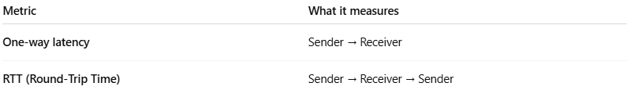
Metric | What it measures
One-way latency | Sender → Receiver
RTT (Round-Trip Time) | Sender → Receiver → Sender
📌 Relationship:
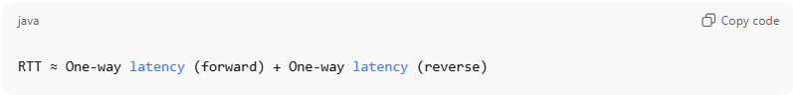
RTT ≈ One-way latency (forward) + One-way latency (reverse)

Simple Example
# Source: AI Source: Provided by: [Data Path: Persons Table -> ID Column: 1, Name_En Column: Motasem Essam] -> From: [ChatGPT] on [12/18/2025]
If:
- Packet takes 30 ms to go from your computer to a server
- Takes 40 ms to come back
Then:
- One-way latency (forward) = 30 ms
- RTT = 70 ms

Why One-way Latency Matters
# Source: AI Source: Provided by: [Data Path: Persons Table -> ID Column: 1, Name_En Column: Motasem Essam] -> From: [ChatGPT] on [12/18/2025]
One-way latency is critical in:
- 🎮 Online gaming
- 📞 VoIP / video calls
- 🚗 Autonomous systems
- 💹 Financial trading
- 📡 Real-time streaming
Even if RTT is acceptable, high one-way latency in one direction can cause:
- Voice delays
- Desynchronization
- Poor real-time performance

How It’s Measured
# Source: AI Source: Provided by: [Data Path: Persons Table -> ID Column: 1, Name_En Column: Motasem Essam] -> From: [ChatGPT] on [12/18/2025]
Measuring one-way latency is harder than RTT because:
- Sender and receiver clocks must be precisely synchronized
Common methods:
- GPS-synchronized clocks
- PTP (Precision Time Protocol – IEEE 1588)
- Specialized network measurement tools
👉 Tools like ping cannot measure one-way latency—only RTT.

Real-World Analogy
# Source: AI Source: Provided by: [Data Path: Persons Table -> ID Column: 1, Name_En Column: Motasem Essam] -> From: [ChatGPT] on [12/18/2025]
- One-way latency: time for a letter to reach your friend
- RTT: time for the letter to reach your friend and get a reply

Summary
# Source: AI Source: Provided by: [Data Path: Persons Table -> ID Column: 1, Name_En Column: Motasem Essam] -> From: [ChatGPT] on [12/18/2025]
- One-way latency measures single-direction delay
- RTT measures round-trip delay
- One-way latency is more important for real-time systems
- Harder to measure due to clock synchronization requirements

2- RTT (Round-Trip Time)

Definition
# Source: AI Source: Provided by: [Data Path: Persons Table -> ID Column: 1, Name_En Column: Motasem Essam] -> From: [ChatGPT] on [12/18/2025]
RTT (Round-Trip Time) is the total time it takes for a data packet to travel from a sender to a receiver and then back to the sender.

RTT = time (sender → receiver → sender)
It measures two-way network delay.

Simple Example
# Source: AI Source: Provided by: [Data Path: Persons Table -> ID Column: 1, Name_En Column: Motasem Essam] -> From: [ChatGPT] on [12/18/2025]
When you use:
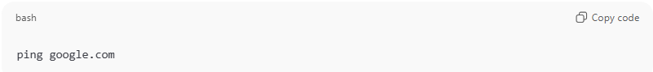
ping google.com
You might see:
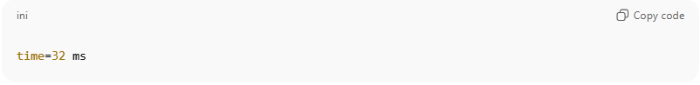
time=32 ms
➡️ This means it took 32 milliseconds for the packet to go to Google’s server and come back.

RTT vs One-Way Latency
# Source: AI Source: Provided by: [Data Path: Persons Table -> ID Column: 1, Name_En Column: Motasem Essam] -> From: [ChatGPT] on [12/18/2025]
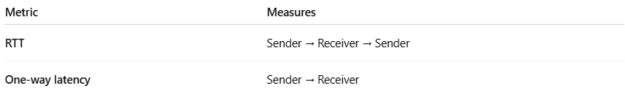
Metric | Measures
RTT | Sender → Receiver → Sender
One-way latency | Sender → Receiver
📌 Relationship:
RTT ≈ Forward latency + Reverse latency

Why RTT Matters
# Source: AI Source: Provided by: [Data Path: Persons Table -> ID Column: 1, Name_En Column: Motasem Essam] -> From: [ChatGPT] on [12/18/2025]
RTT directly affects:
- 🌐 Web page load time
- 🎮 Online gaming responsiveness
- 📞 Voice & video call quality
- 🗄️ Database and API performance
- ☁️ Cloud application latency
High RTT = slow responses, even if bandwidth is high.

How RTT Is Measured
# Source: AI Source: Provided by: [Data Path: Persons Table -> ID Column: 1, Name_En Column: Motasem Essam] -> From: [ChatGPT] on [12/18/2025]
- Most commonly measured using ping
- Ping sends an ICMP Echo Request
- Receives an ICMP Echo Reply
- Measures elapsed time = RTT

Typical RTT Values
# Source: AI Source: Provided by: [Data Path: Persons Table -> ID Column: 1, Name_En Column: Motasem Essam] -> From: [ChatGPT] on [12/18/2025]
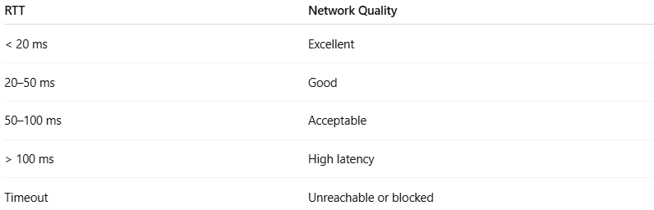
RTT | Network Quality
< 20 ms | Excellent
20–50 ms | Good
50–100 ms | Acceptable
> 100 ms | High latency
Timeout | Unreachable or blocked

Real-World Analogy
# Source: AI Source: Provided by: [Data Path: Persons Table -> ID Column: 1, Name_En Column: Motasem Essam] -> From: [ChatGPT] on [12/18/2025]
- Asking a question and waiting for the answer
- RTT = time to ask plus time to hear the reply

Key Points to Remember
# Source: AI Source: Provided by: [Data Path: Persons Table -> ID Column: 1, Name_En Column: Motasem Essam] -> From: [ChatGPT] on [12/18/2025]
- RTT measures two-way delay
- Easier to measure than one-way latency
- Commonly used in network diagnostics
- Does not measure bandwidth or throughput

One-line Summary
# Source: AI Source: Provided by: [Data Path: Persons Table -> ID Column: 1, Name_En Column: Motasem Essam] -> From: [ChatGPT] on [12/18/2025]
RTT is the time for a packet to go to a destination and return to the sender.
If you want, I can also explain RTT vs latency vs jitter, or how RTT impacts TCP performance.

⏱ Example
# Source: AI Source: Provided by: [Data Path: Persons Table -> ID Column: 1, Name_En Column: Motasem Essam] -> From: [ChatGPT] on [12/18/2025]
- You ping a server and get a reply in 40 ms
→ That means 40 milliseconds of round-trip latency

🧪 What Causes Latency?
# Source: AI Source: Provided by: [Data Path: Persons Table -> ID Column: 1, Name_En Column: Motasem Essam] -> From: [ChatGPT] on [12/18/2025]
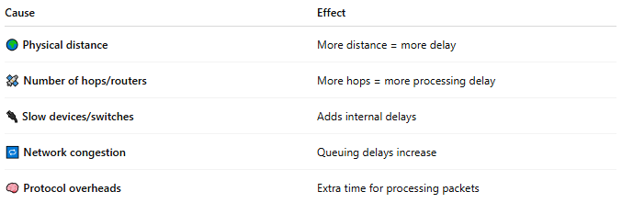
Cause | Effect
🌍 Physical distance | More distance = more delay
🛰️ Number of hops/routers | More hops = more processing delay
🔌 Slow devices/switches | Adds internal delays
🔁 Network congestion | Queuing delays increase
🧠 Protocol overheads | Extra time for processing packets

🕹️ Why Latency Matters
# Source: AI Source: Provided by: [Data Path: Persons Table -> ID Column: 1, Name_En Column: Motasem Essam] -> From: [ChatGPT] on [12/18/2025]
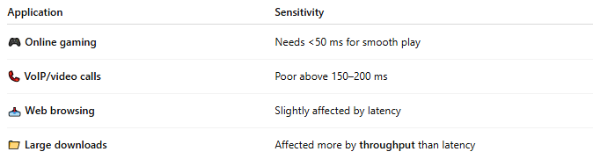
Application | Sensitivity
🎮 Online gaming | Needs <50 ms for smooth play
📞 VoIP/video calls | Poor above 150–200 ms
📥 Web browsing | Slightly affected by latency
📁 Large downloads | Affected more by throughput than latency

🆚 Latency vs Bandwidth vs Throughput
# Source: AI Source: Provided by: [Data Path: Persons Table -> ID Column: 1, Name_En Column: Motasem Essam] -> From: [ChatGPT] on [12/18/2025]
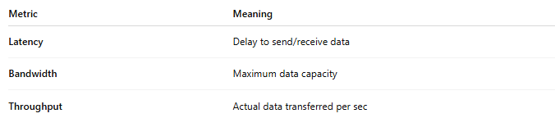
Metric | Meaning
Latency | Delay to send/receive data
Bandwidth | Maximum data capacity
Throughput | Actual data transferred per sec
📌 Analogy:
Bandwidth = size of the pipe
Latency = how fast the water starts coming out after turning the tap
Throughput = how much water actually comes through per second

📌 Summary
# Source: AI Source: Provided by: [Data Path: Persons Table -> ID Column: 1, Name_En Column: Motasem Essam] -> From: [ChatGPT] on [12/18/2025]
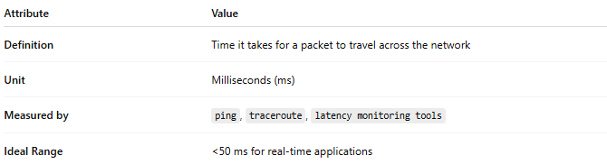
Attribute | Value
Definition | Time it takes for a packet to travel across the network
Unit | Milliseconds (ms)
Measured by | ping, traceroute, latency monitoring tools
Ideal Range | <50 ms for real-time applications

